Kepler’s Laws

Gravitation

Rotation around rigid body



G =/ g

G same value for all location

G different location = different values

**Since W = mg**



Escape Velocity Circular motion.



Angular Momentum

Rotation around rigid body

L = angular momentum

Terminal velocity

Air drags at high speed

Rotational Dynamic

Torque

* Torque is a vector.
* >= 2 force acting on rigid body, torque is positive is counter-CW, else negative if CW

Torque & angular acceleration.

Work, power, energy.

P = tw

Torque vs force

Static Equilibrium

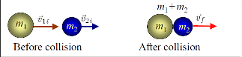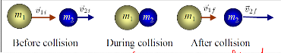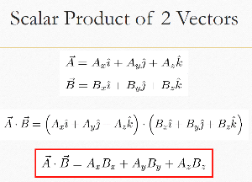

Time present = use at

Else use ar (if ask for centipedal, use ar)

Arc length

Radial acceleration

tangent acceleration

Moment of Inertia for different objects

Moment of Inertia

Angular Motion (Rotational motion of body)

Kinematics (Angular vs Linear)

θ – θ0 = 1/2(ω0 + ω) t

θ => can be used to find m and angle/rad

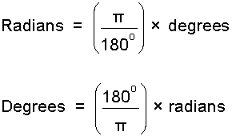

Centre of Mass (Shaped object)

Centre of Mass (System of particles)

Centre of Mass (Extended Object)

Characteristics of CM

Centre of mass (Right angle triangle)

Centre of mass (Cone)

Motion of system of particles

Momentum and Collision

P = mv (Momentum)

P = KE =

**Remember where all forces and momentum are present.**

Elastic Collision

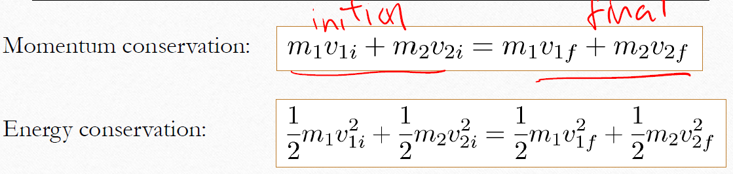

Final Velocity

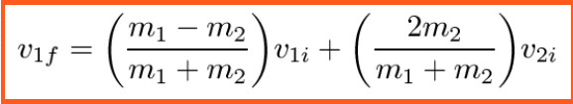 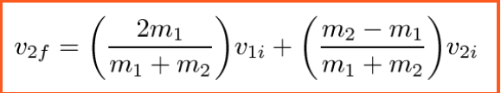

Inelastic Collision

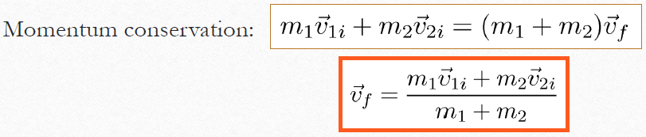

Inelastic Collision

**Momentum found at collision.**

Properties of conservative force

Force is independent of path.

Force at end = Force at start

Power

Pinst = mv(Momentum)

Pav = W/t

SI unit : Watt(W)

1 horsepower = 746W

1 kWh = 103 x 3600 W = 3.6 MJ

instantaneous power:

Reminder

F = μmg = ma = mg

J = F x T

Work Done

**W = F . S(Constant)(SI: J)**

**W = KE = ½mv^2(Kinetic)**

**W = GPE = mg**

**h (Gravitational)**

**W = SE = ½kx^2(Spring)**

**W = KE = ½mv^2­­f – ½v^2i**

**W = KEf + GPEf = KEi + GPEi**

**(Same idea for GPE & SE when displacement occur)**

**Momentum from start and end is the same(conserved)** 

**Mechanical energy (ME) = KE = GPE = SE**

**I =½**MR^2

Application of Newton’s Laws

**Uniform Circular motion** **Negotiating a Curve**

**Negotiating a Bank Curve Non-Uniform Circular**

**Motion**

